**CUMMULATIVE ASSESSMENT – 1**

**Ques 1:**

package Ques1;

import org.openqa.selenium.By;

import org.openqa.selenium.WebDriver;

import org.openqa.selenium.WebElement;

import org.openqa.selenium.chrome.ChromeDriver;

import org.openqa.selenium.chrome.ChromeOptions;

import io.github.bonigarcia.wdm.WebDriverManager;

public class Q1 {

public static void main(String[] args) throws InterruptedException

{

WebDriverManager.*chromedriver*().setup ();

WebDriver driver;

ChromeOptions co=new ChromeOptions();

co.addArguments("--remote-allow-origins=*");

driver=new ChromeDriver(co);

driver.manage().window().maximize();

driver.navigate().to("https://www.amazon.in/OnePlus-Bluetooth-Wireless-Co-Created-Cancellation/dp/B0BRSLJCY2/ref=sr_1_1_sspa?keywords=oneplus+buds&qid=1683195173&sr=8-1-spons&sp_csd=d2lkZ2V0TmFtZT1zcF9hdGY&psc=1");

WebElement addtocart=driver.findElement(By.*id*("add-to-cart-button"));

addtocart.click();

Thread.*sleep*(2000);

WebElement cart=driver.findElement(By.*xpath*("//*[@id=\"attach-sidesheet-view-cart-button\"]/span/input"));

cart.click();

Thread.*sleep*(2000);

driver.findElement(By.*id*("a-autoid-0-announce")).click();

driver.findElement(By.*xpath*("//*[@id=\"quantity_4\"]")).click();

driver.findElement(By.*xpath*("//*[@id=\"sc-buy-box-ptc-button\"]/span/input")).click();

Thread.*sleep*(2000);

WebElement proceedtobuy=driver.findElement(By.*name*("proceedToRetailCheckout"));

proceedtobuy.click();

System.***out***.print("Checked out Sucessfully");

}

}

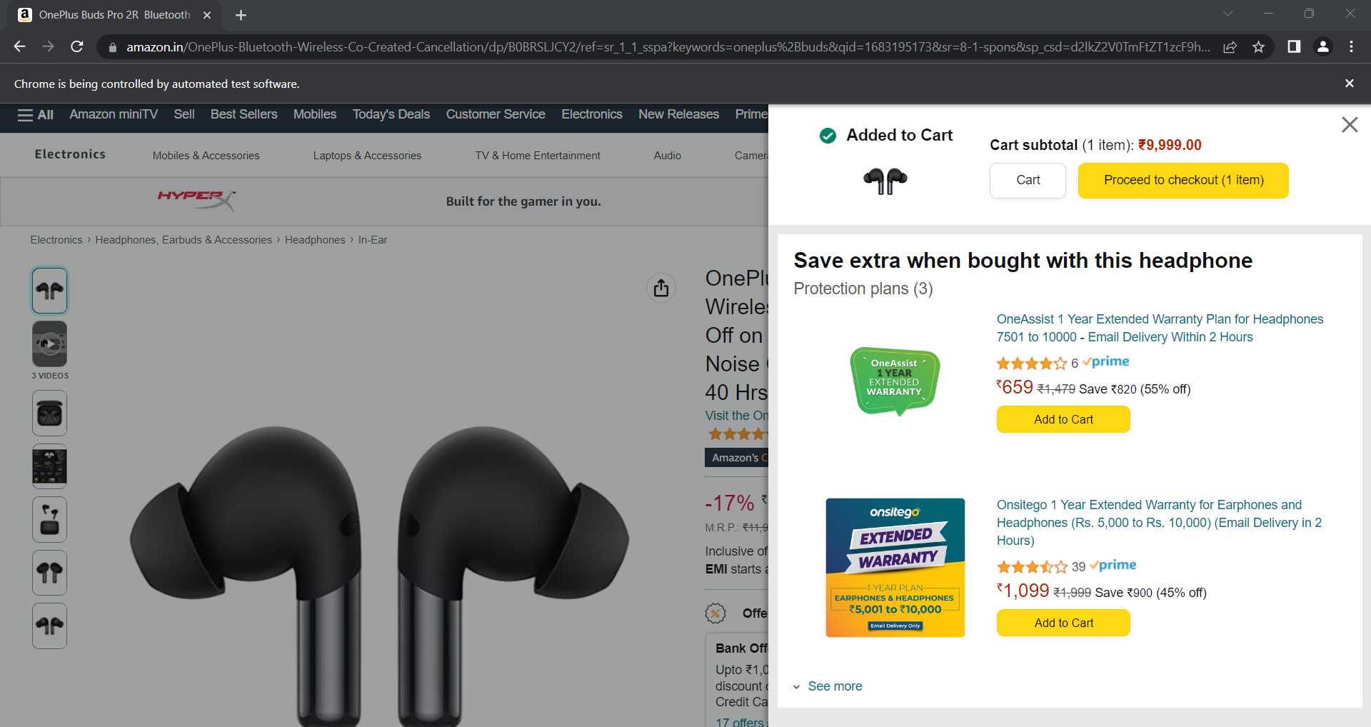

**Ques 2:**

package Ques2;

import org.openqa.selenium.By;

import org.openqa.selenium.WebDriver;

import org.openqa.selenium.WebElement;

import org.openqa.selenium.chrome.ChromeDriver;

import org.openqa.selenium.chrome.ChromeOptions;

import io.github.bonigarcia.wdm.WebDriverManager;

public class Q2 {

public static void main(String[] args) throws InterruptedException {

// **TODO** Auto-generated method stub

ChromeOptions co=new ChromeOptions();

co.addArguments ("--remote-allow-origins=*");

WebDriverManager.*chromedriver*().setup ();

WebDriver driver=new ChromeDriver(co);

driver.manage().window().maximize() ;

driver.get ("https://www.amazon.in/");

String currentTitle=driver.getTitle();

System.***out***.println(currentTitle);

String expectedTitle="Online Shopping site in India: Shop Online for Mobiles, Books, Watches, Shoes and More - Amazon.in";

if(currentTitle.equals(expectedTitle)) {

System.***out***.println("Title Matched");

}

else {

System.***out***.println("Title not Matched");

}

WebElement txtBoxl=driver.findElement(By.*xpath*("//*[@id=\"twotabsearchtextbox\"]"));

txtBoxl.sendKeys("android");

driver.findElement(By.*xpath*("//*[@id=\"nav-search-submit-button\"]")).click();

String str1=driver.findElement(By.*xpath*("//*[@id=\"search\"]/div[1]/div[1]/div/span[1]/div[1]/div[3]/div/div/div/div/div/div/div/div[2]/div/div/div[1]/h2/a/span")).getText();

System.***out***.println(str1);

String str2=driver.findElement(By.*xpath*("//*[@id=\"search\"]/div[1]/div[1]/div/span[1]/div[1]/div[4]/div/div/div/div/div/div/div/div[2]/div/div/div[1]/h2/a/span")).getText();

System.***out***.println(str2);

String str3=driver.findElement(By.*xpath*("//*[@id=\"search\"]/div[1]/div[1]/div/span[1]/div[1]/div[5]/div/div/div/div/div/div[2]/div/div/div[1]/h2/a/span")).getText();

System.***out***.println(str3);

String str4=driver.findElement(By.*xpath*("//*[@id=\"search\"]/div[1]/div[1]/div/span[1]/div[1]/div[6]/div/div/div/div/div/div[2]/div/div/div[1]/h2/a/span")).getText();

System.***out***.println(str4);

String str5=driver.findElement(By.*xpath*("//*[@id=\"search\"]/div[1]/div[1]/div/span[1]/div[1]/div[7]/div/div/div/div/div/div[2]/div/div/div[1]/h2/a/span")).getText();

System.***out***.println(str5);

Thread.*sleep*(4000);

driver.findElement(By.*xpath*("//*[@id=\"p_n_feature_thirty-one_browse-bin/51258698031\"]/span/a/span")).click();

driver.findElement(By.*xpath*("//*[@id=\"p_89/OnePlus\"]/span/a/span")).click();

}

}

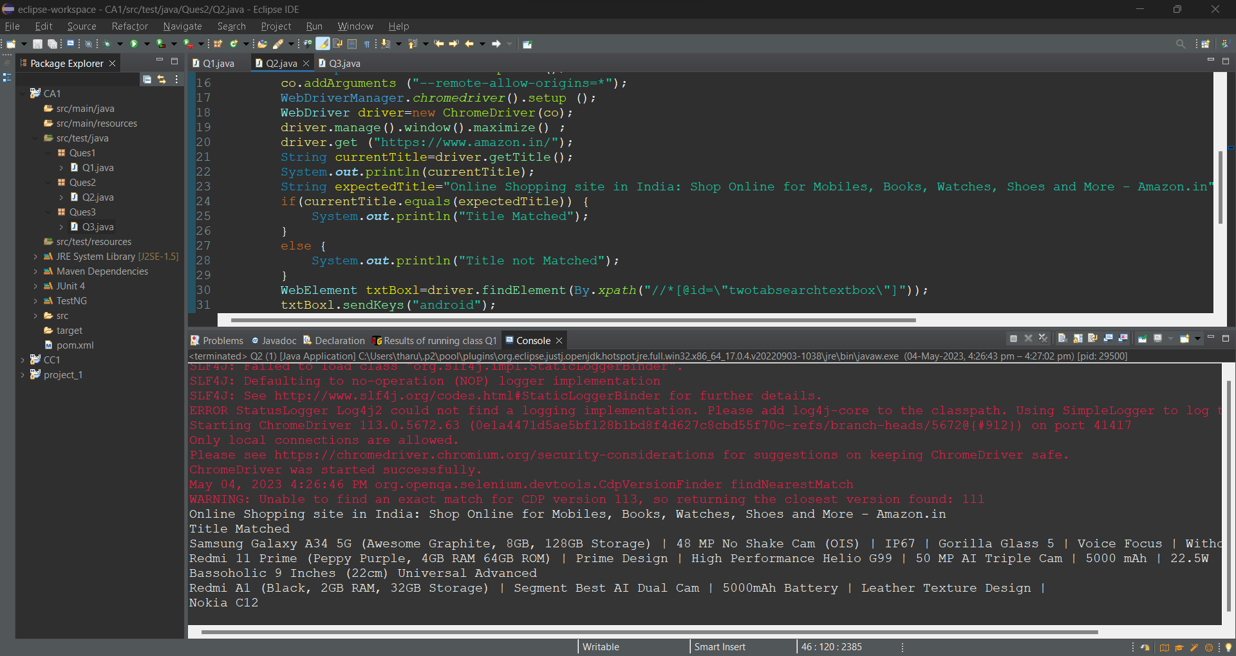

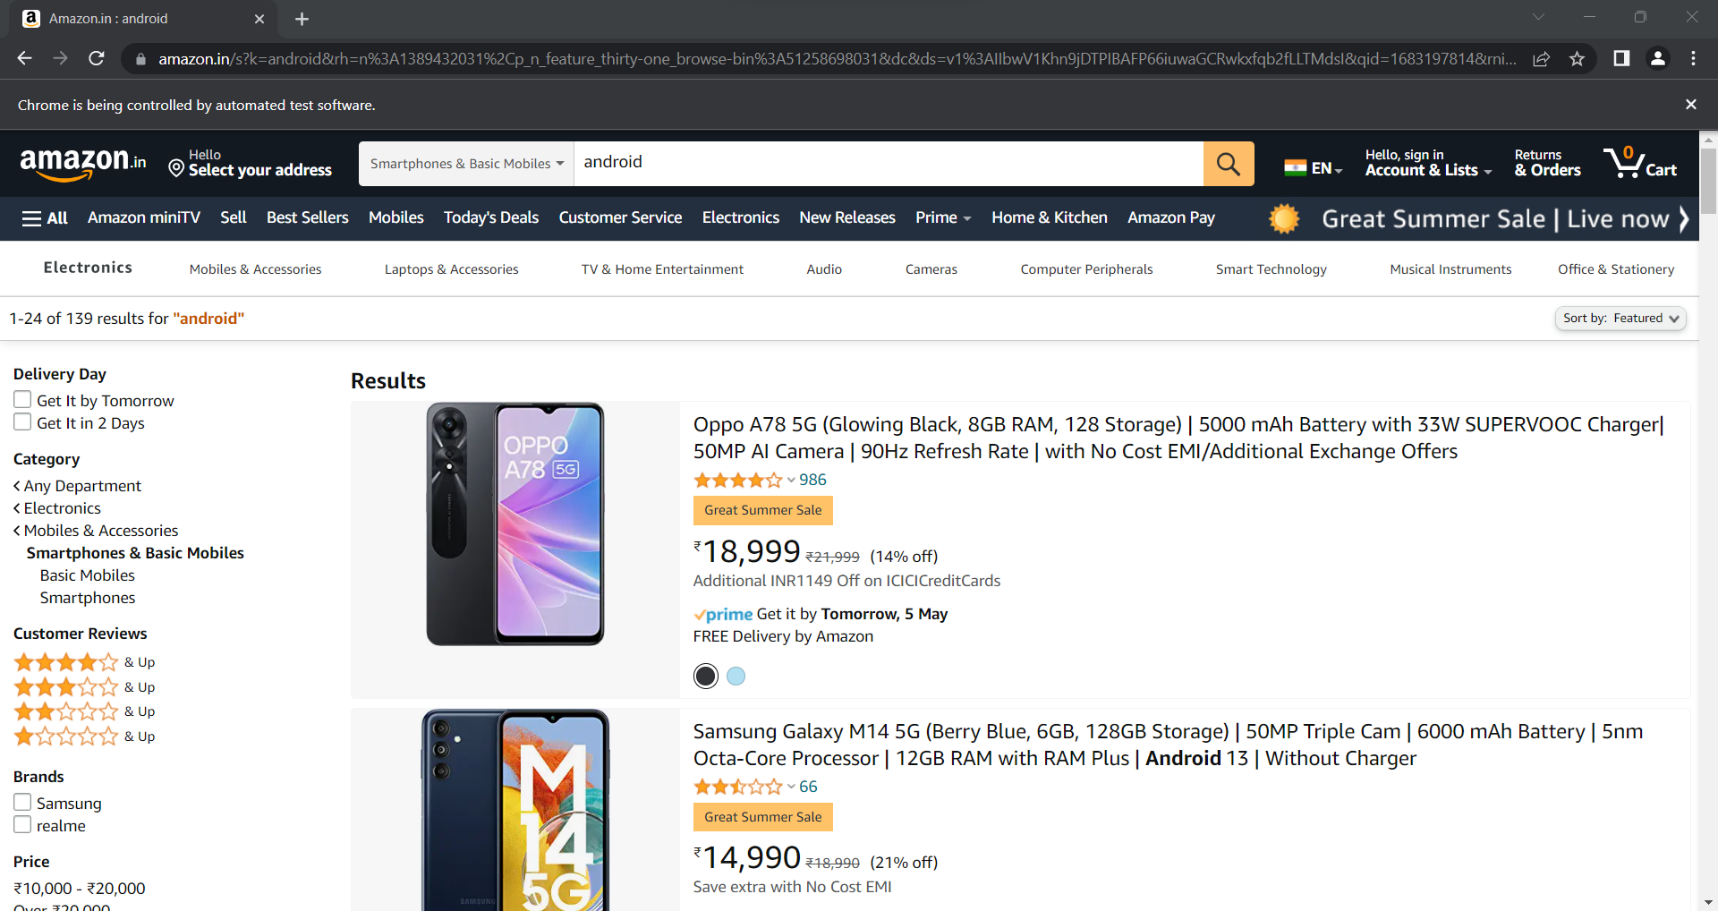

**Ques 3:**

package Ques3;

import org.openqa.selenium.By;

import org.openqa.selenium.WebDriver;

import org.openqa.selenium.WebElement;

import org.openqa.selenium.chrome.ChromeDriver;

import org.openqa.selenium.chrome.ChromeOptions;

import io.github.bonigarcia.wdm.WebDriverManager;

public class Q3 {

public static void main(String[] args) {

ChromeOptions co=new ChromeOptions();

co.addArguments ("--remote-allow-origins=*");

WebDriverManager.*chromedriver*().setup ();

WebDriver driver=new ChromeDriver(co);

driver.manage().window().maximize() ;

driver.get ("https://www.amazon.in/");

String currentTitle=driver.getTitle();

System.***out***.println(currentTitle);

String expT="Online Shopping site in India: Shop Online for Mobiles, Books, Watches, Shoes and More - Amazon.in";

if(currentTitle.equals(expT)) {

System.***out***.println("Title Matched");

}

else {

System.***out***.println("Title not Matched");

}

driver.findElement(By.*xpath*("//*[@id=\"nav-link-accountList\"]")).click();

WebElement boxl=driver.findElement(By.*xpath*("//*[@id=\"ap_email\"]"));

boxl.sendKeys("+917010071577");

driver.findElement(By.*xpath*("//*[@id=\"continue\"]")).click();

WebElement box2=driver.findElement(By.*xpath*("//*[@id=\"ap_password\"]"));

box2.sendKeys("kaviya2000");

driver.findElement(By.*xpath*("//*[@id=\"signInSubmit\"]")).click();

driver.findElement(By.*xpath*("//*[@id=\"nav-link-accountList\"]")).click();

driver.findElement(By.*xpath*("//*[@id=\"a-page\"]/div[2]/div/div[2]/div[1]/a/div/div")).click();

driver.findElement(By.*xpath*("//*[@id=\"a-autoid-2-announce\"]")).click();

driver.findElement(By.*xpath*("//*[@id=\"ordersInPackage-container\"]/div/div/a[1]")).click();

}

}

